192110630

Sk. Shailu begum.

1. Write a C++ program to demonstrate the overloading of a unary operator.

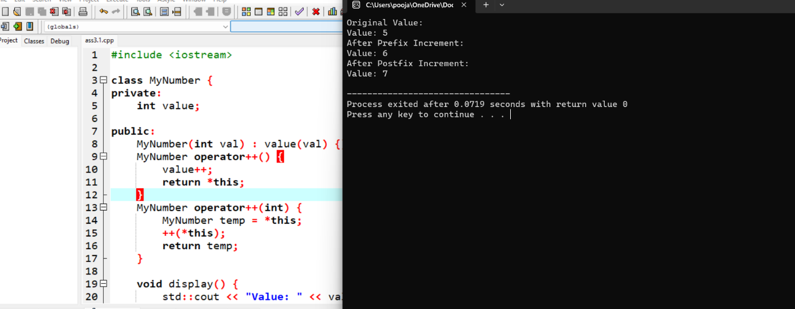

1. Write a C++ program to demonstrate the overloading of a binary operator.

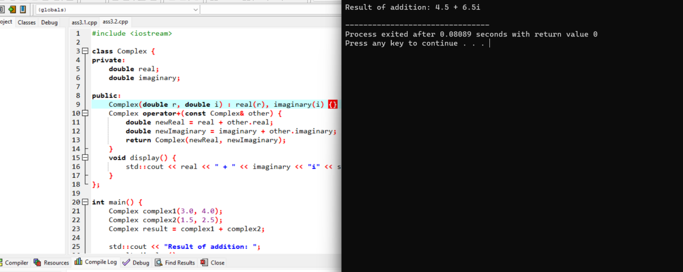

1. What is the output of the following code?

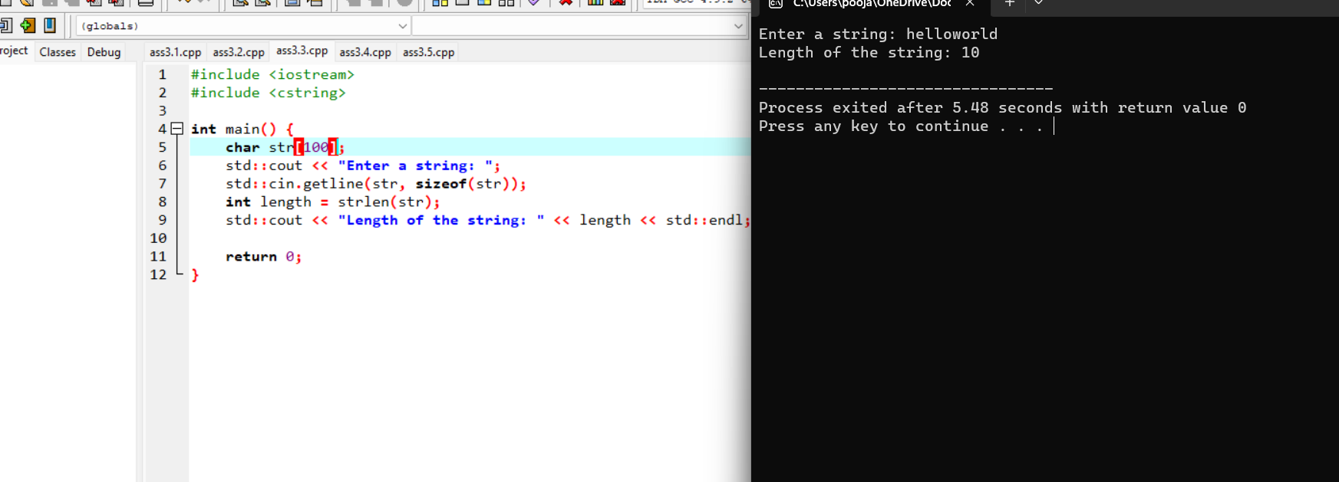

1. What is the output of the following code?

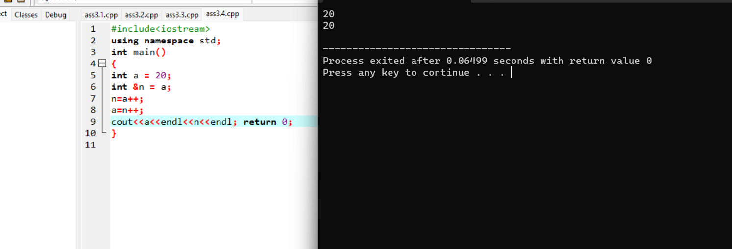

1. Write down a C++ program to implement function overloading.

